DataStrcuture Unit 1 QuestionBank Wise Answers :

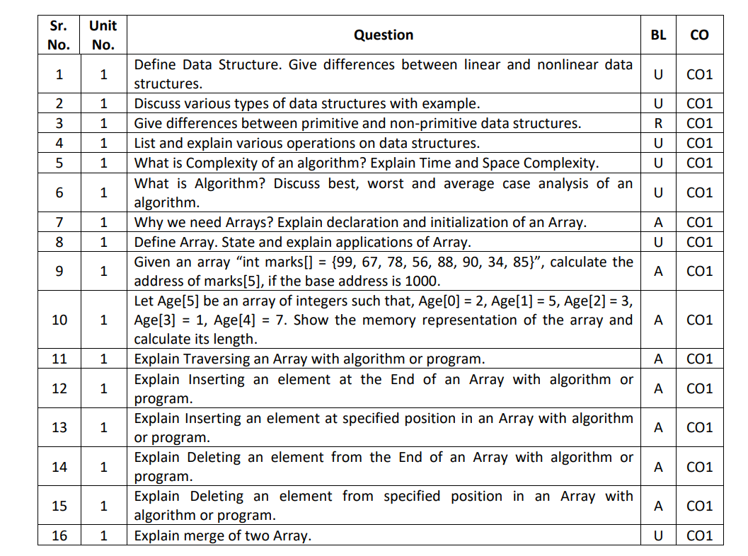

**1. Define Data Structure. Give differences between linear and non-linear data structures.**

* Data Structure:  
  A data structure is a way of organizing and storing data so it can be used efficiently. For example, if you want to store and access a list of student names, you can use an array.
* Linear vs. Non-Linear Data Structures:

|  |  |
| --- | --- |
| Linear Data Structure | Non-Linear Data Structure |
| Data is arranged in a sequence. | Data is arranged hierarchically or non-sequentially. |
| Each element is connected to the next. | Elements can connect to multiple other elements. |
| Examples: Arrays, Linked Lists, Stacks, Queues. | Examples: Trees, Graphs. |

**2. Discuss various types of data structures with examples.**

* 1. Primitive Data Structures: Built-in types provided by the language. Examples:
  + int, char, float in C/C++.
* 2. Linear Data Structures: Data is arranged in a sequence. Examples:
  + Array: A list of elements (e.g., [1, 2, 3, 4]).
  + Stack: Follows LIFO (Last In, First Out) principle (like a stack of books).
  + Queue: Follows FIFO (First In, First Out) principle (like a line at a bank).
* 3. Non-Linear Data Structures: Data is arranged hierarchically. Examples:
  + Tree: Used for hierarchical data like a family tree.
  + Graph: Used for networks like social media connections.
* 4. Hashing: Used for fast lookups.
  + Example: A phone book where you can directly search for a name.

**3. Differences between primitive and non-primitive data structures.**

|  |  |
| --- | --- |
| Primitive Data Structures | Non-Primitive Data Structures |
| Basic types provided by the programming language. | Derived from primitive types. |
| Examples: int, float, char. | Examples: Arrays, Linked Lists, Trees, Graphs. |
| Stores single values. | Stores multiple values or data relationships. |

**4. List and explain various operations on data structures.**

* Common operations:
* Insert: Add elements.
* Delete: Remove elements.
* Search: Find elements.
* Sort: Arrange in order.
* Traverse: Access each element

1. Traversing

* Definition: Accessing and visiting each element of the data structure one by one.
* Example: Reading all elements of an array [10, 20, 30, 40].
* Purpose: To analyze or display the data.
* Example Code:
* for(int i = 0; i < n; i++) {
* printf("%d", arr[i]); // Access each element
* }

2. Insertion

* Definition: Adding a new element to a data structure.
* Purpose: To expand or update the data.
* Example: Adding 50 to an array [10, 20, 30] at the end becomes [10, 20, 30, 50].
* Types of Insertion:
  1. At the beginning.
  2. At the end.
  3. At a specific position.

3. Deletion

* Definition: Removing an element from a data structure.
* Purpose: To shrink or update the data.
* Example: Removing 20 from [10, 20, 30] results in [10, 30].
* Types of Deletion:
  1. From the beginning.
  2. From the end.
  3. From a specific position.

4. Searching

* Definition: Finding the location of a specific element in the data structure.
* Purpose: To retrieve or work with specific data.
* Example: Searching for 30 in [10, 20, 30, 40] gives the position 2 (index starts at 0).
* Methods:
  + Linear Search: Search one element at a time.
  + Binary Search: Search by dividing the data (faster, works for sorted data).

5. Sorting

* Definition: Arranging the elements of the data structure in a specific order.
* Purpose: To organize data for easy searching or processing.
* Example: Sorting [40, 10, 30, 20] in ascending order results in [10, 20, 30, 40].
* Types of Sorting:
  + Ascending (small to large).
  + Descending (large to small).

6. Merging

* Definition: Combining two or more data structures into one.
* Purpose: To unite datasets.
* Example: Merging [10, 20] and [30, 40] results in [10, 20, 30, 40].

8. Updating

* Definition: Modifying an existing element in the data structure.
* Purpose: To correct or change data.
* Example: In array [10, 20, 30], updating arr[1] = 50 changes the array to [10, 50, 30].

**5. What is Complexity of an algorithm? Explain Time and Space Complexity.**

* Algorithm Complexity: It measures how efficiently an algorithm works in terms of time and space.

1. Time Complexity:
   * How much time an algorithm takes to run.
   * Example: Searching a number in a list.
     + If the list has 5 numbers, it’s faster. If it has 1 million numbers, it takes more time.
2. Space Complexity:
   * How much memory an algorithm needs.
   * Example: If you store 100 numbers in an array, you need memory for 100 numbers.

**6. What is Algorithm? Discuss best, worst, and average-case analysis.**

* Algorithm: A step-by-step method to solve a problem. Example: A recipe for cooking food is an algorithm.
* Analysis Types:
  + Best Case: The algorithm works in the least time.
    - Example: Searching for the first element in a list.
  + Worst Case: The algorithm takes the most time.
    - Example: Searching for an element not present in the list.
  + Average Case: The time is somewhere between the best and worst case.

**7. Why do we need Arrays? Explain declaration and initialization of an Array.**

* Why Arrays:  
  An array is useful to store multiple values of the same type under one name. For example, instead of creating 10 variables for 10 student marks, we can use one array like marks[10].
* Declaration and Initialization:
  + Declaration: This creates the array.
    - Example: int arr[5]; creates an array of size 5.
  + Initialization: This assigns values to the array.
    - Example: arr[0] = 10; arr[1] = 20;

**8. Define Array. State and explain applications of Array. ans in details**

Definition of an Array

An array is a collection of elements, all of the same data type, stored in contiguous memory locations. Arrays allow storing multiple values under a single name, making it easier to manage and process data.

* Example:  
  If you want to store marks of 5 students, instead of using 5 separate variables (marks1, marks2, etc.), you can use an array:  
  marks[5] = {90, 85, 78, 92, 88};

Features of an Array

1. Fixed Size: The size of the array is defined at the time of declaration.
2. Homogeneous Elements: All elements in the array must be of the same type (e.g., integers, floats).
3. Indexed Access: Each element can be accessed using its index.
   * Example: marks[0] gives the first element of the array.

Syntax of an Array

Declaration : data_type array_name[size];

Example : int marks[5]; // Array of size 5 to store integers

Initialization

marks[0] = 90; // Assign value to the first element

marks[1] = 85; // Assign value to the second element

Applications of Arrays

1. Storing Data

Arrays are used to store multiple elements of the same type in a structured way.

* Example: Storing marks of 100 students, storing monthly sales data, etc.

2. Searching

Arrays are used in algorithms like Linear Search and Binary Search to find elements in a dataset.

* Example: Searching for a specific product ID in a list of IDs.

3. Sorting

Arrays are used in sorting algorithms like Bubble Sort, Merge Sort, and Quick Sort to arrange data in ascending or descending order.

* Example: Sorting exam scores or employee salaries.

4. Matrix Representation

Arrays can represent 2D and 3D matrices, which are useful in mathematical and scientific computations.

* Example: Representing a chessboard (2D grid) or 3D game environments.

5. Temporary Data Storage

Arrays are often used as buffers to store temporary data during program execution.

* Example: Storing characters while reading a string or file.

6. Implementing Data Structures

Other data structures, such as stacks, queues, and heaps, are built using arrays.

* Example: A stack uses an array to manage its elements.

7. Image Processing

Arrays are used to store pixel values of images, where each pixel corresponds to an element in the array.

* Example: A black-and-white image is stored as a 2D array of 0s and 1s.

8. Managing Database Records

Arrays can be used to store and process records like employee data, student information, or customer details.

* Example: Storing 100 employee IDs in an array.

Advantages of Arrays

1. Efficient Access: Accessing elements is fast using their index.
2. Compact Storage: Stores elements in contiguous memory, saving space.
3. Ease of Use: Simple to declare and manipulate.

Disadvantages of Arrays

1. Fixed Size: Cannot change the size once declared.
2. Inefficient Insertion/Deletion: Shifting elements is required, which can be time-consuming.
3. Homogeneous Data: Only one data type is allowed.

**9. Calculate the address of marks[5] if the base address is 1000.**

* Formula: Address = Base + (Index × Size of element).
* If int is 4 bytes:  
  1000 + (5 × 4) = 1020.

**10. Memory representation of Age[5]:**

* Array: Age[5] = {2, 5, 3, 1, 7}.
* Length: 5.
* Memory layout: Age[0], Age[1], … stored sequentially.

**11. Explain Traversing an Array with an algorithm or program.**

* Traversing: Visiting each element.  
  Algorithm:

for(i = 0; i < n; i++) {

print(arr[i]); }

**12. Explain Inserting an element at the End of an Array.**

* Algorithm:

arr[n] = newElement;

n++;

**13. Explain Inserting at a specified position.**

* Algorithm:

for(i = n; i >= pos; i--) {

arr[i] = arr[i-1];

}

arr[pos] = newElement;

n++;

**14. Deleting an element from the End of an Array.**

* Algorithm:

n--;

**15. Deleting from a specified position.**

* Algorithm:

for(i = pos; i < n-1; i++) {

arr[i] = arr[i+1];

}

n--;

**16. Explain the merge of two Arrays.**

* Combine two arrays into one.
* Algorithm:

for(i = 0; i < n1; i++)

result[i] = arr1[i];

for(j = 0; j < n2; j++)

result[n1+j] = arr2[j];